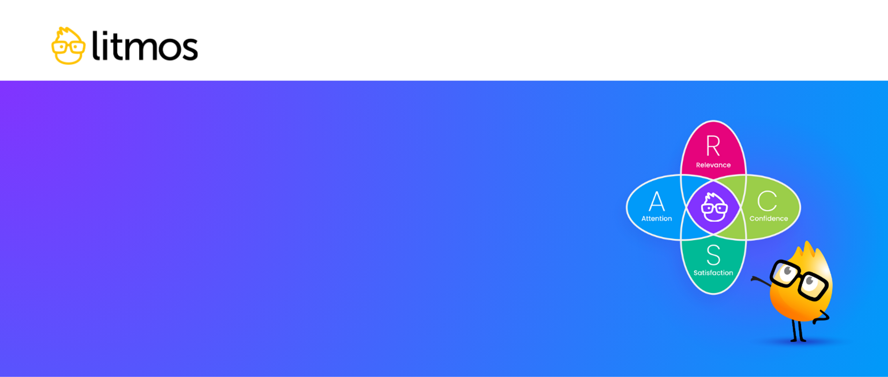
Motivational Design Checklist
This easy step-by-step checklist will help you follow the ARCS
Model (Attention, Relevance, Confidence, Satisfaction) for
motivational design in Learning & Development (L&D). Instructional
Designers and other learning professionals can use this checklist
to build more motivational eLearning programs that boost learner
confidence and competency.
Please note: the examples included in this checklist are not exhaustive. This resource
is meant to be customized for your specific industry, company, or onboarding needs
.

Objectives to Define
☐ | Business goals  identify what business goals your learning program needs to meet.
☐ | Learning outcomes  identify key learning outcomes your organization hopes to achieve through training.
☐ | Skills requirements  identify which skills your organization wants to develop through training.

Key Learning Material Criteria
☐ | Personalization  content is tailored to learner role, responsibilities, goals, challenges, and preferences.
☐ | Interactivity  content includes points of engagement like quizzes, simulations, discussion boards, etc.
☐ | Formal Measurability  content integrates formal assessments as opportunities for assessing level of mastery.
☐ | Informal Measurability  content integrates informal assessments as opportunities for practicing skills in a  low-stakes environment.
☐ | Focused on Providing Performance Feedback  content embeds multiple ways for learners to receive feedback on their performance
☐ | Focused on Facilitating Learner Feedback  content embeds multiple ways for learners to share their thoughts on the subject matter and delivery of the course materials

ARCS Model for Learning Design
 | Attention  Keep learners actively engaged with interactive activities like quizzes, simulations, & discussions.
☐ | Present surprising facts to grab attention and make learning memorable.
☐ | Use multimedia elements to keep learning interesting.
☐ | Incorporate interactive elements to keep learners engaged.

 | Relevance  Give learners a sense of autonomy and ownership over their training with customized training.
☐ | Use simulations to make learning resonate.
☐ | Highlight real-world examples to show the relevance of learning materials.
☐ | Customize training with AI learning playlists and personalized learning paths.

 | Confidence  Provide opportunities for practice so learners can apply newly acquired  skills in a low-stakes environment.
☐ | Set achievable goals to provide learners with a roadmap for their development and foster a sense of purpose.
☐ | Provide clear instructions to help learners feel that they can successfully master the material.
☐ | Offer avenues for support to enhance motivation and positive associations with the overall learning experience.
☐ | Build feedback into coursework to empower learners and improve future learning experiences.

 | Satisfaction  Publicly acknowledge and reward learning activities to build a sense of accomplishment  and foster a stronger culture of learning.
☐ | Publicly recognize learning accomplishments to give learners a sense of pride.
☐ | Reward learning with financial or career-related incentives to motivate learners to participate in continuous training.
☐ | Gamify learning with leaderboards, badges, and certificates to encourage friendly competition and drive completion.

